A First Project Report On

TechJobs - Connecting Tech Talent to

Tomorrow’s Opportunities

Submitted in Partial Fulfillment of the Requirements for the Degree of

Bachelor of Engineering in Information Technology

under Pokhara University

Submitted by:

Aarati Rai, 211402

Shreya Shrestha, 211438

January 24, 2024



## Acknowledgement

This project would not have been possible without the joint effort of many individuals. It has been a pleasure for us to acknowledge this assistance and contributions that were very important and supportive throughout the project. We would like to extend our sincere thanks to all of them who have devoted much of their time and expertise without which it would have been very difficult for us to complete our project entitled “TechJobs”.

Last,but not the least, We express our heartfelt gratitude to Nepal College of Information Technology for its support and technical environment for our project, which is a part of our curriculum. A special thanks to respected sir , Er. Subash Manandhar, whose help, stimulating suggestions and encouragement, technical support helped us to coordinate our project especially in writing this report.

## Abstract

TechJobs is a dynamic platform designed to revolutionize the way employer and employee connect in the ever-evolving landscape of the technology industry. This platform helps to streamline the job search and recruitment processes, addressing the unique challenges faced by both job seekers and employers in the tech sector.

For job seekers, TechJobs offers a user-friendly interface with advanced search. The platform employs state-of-the-art algorithms to match candidates with positions that align with their skills, experience, and career aspirations. Additionally, TechJobs provides a comprehensive suite of resources, including career development insights, skill enhancement opportunities, and networking events, empowering individuals to thrive in their tech careers.

Employers can showcase their company culture, values, and projects through multimediarich profiles, attracting top-tier talent. TechJobs also facilitates communication between recruiters and candidates, enhancing the overall recruitment experience.

Furthermore, This project plays main role at admin side for recruitment process. The start dates and end dates for applications, the job vacancies, postings, deleting , modifying the privileges etc. are the special features of this system.

Contents

Acknowledgement I

Abstract II

List of Figures IV

1 Introduction 1

2 Problem Statement 2

3 Problem Objectives 3

4 Scope and Limitations 4

4.1 Scope 4

4.2 Limitations: 4

5 Significance of the study 5

6 Literature Review 6

6.1 Similar works 6

7 Methodology 7

7.1 Increment Model 9

7.2 Technology and Frameworks 10

8 Conclusion and Future Extensions 12

References 13

## List of Figures

1. Use Case Diagram . . . . . . . . . . . . . . . . . . . . . . . . . . . . . . . 7
2. E-R Diagram . . . . . . . . . . . . . . . . . . . . . . . . . . . . . . . . . 8
3. Increment Model . . . . . . . . . . . . . . . . . . . . . . . . . . . . . . . 9

# Introduction

Welcome to TechJobs, where great careers meet top talent! Our platform connects job seekers with exciting opportunities and helps employers find the perfect candidates. With user-friendly features and advanced search options, finding your next career move or ideal candidate has never been easier.

Our project “TechJobs-Online Job Portal”, a web, is a platform where jobs are posted and viewed by the users. Lists of job are displayed in job list. This web-based portal is basically concerned with different job services provided by different companies. It is also concerned with details of job seekers. Job seeker can view the list of different jobs and can apply for the jobs. Then the company selects the required job seeker for their qualification and update the database. The admin will manage this website.

# Problem Statement

In today’s dynamic job market, job portals play a crucial role in addressing several key challenges faced by both job seekers and employers.For job seekers, finding the right job that matches their skills, qualifications and experience can be difficult. Additionally, the process of applying for jobs can be time-consuming and frustrating, especially when faced with outdated or inaccurate job listings.On the other hand, employers often encounter difficulties in sourcing and attracting qualified candidates efficiently. The traditional recruitment process can be laborious and costly, with challenges in identifying the right talent for specific roles. This can result in prolonged vacancies and increased recruitment expenses.

1. Improper company description.
2. Lack of centralized database and difficulty in accessing and managing job records.
3. Job seekers may provide fake resume.

# Problem Objectives

The objective of our project is to develop a dynamic online job portal that eliminates difficulties in sourcing and attracting qualified candidates efficiently.Our goal is to create a user-friendly, efficient, and effective system that benefits both job seekers and employers in their quest for employment and talent, respectively. The main aim of the project is:

1. To provide information about new jobs.
2. To eliminate difficulties in sourcing and attracting qualified candidates efficiently .
3. To create a user-friendly system that acts as a single platform for both companies andjob seekers.

# Scope and Limitations

## Scope

The scope of this system is to create a user-friendly platform that connects job seekers with employers, and provides valuable resources to support career development.. Our system provides the following scope:

1. Maintain Job Seeker and Employer records.
2. Maintain Job Posting details and generate various reports.
3. Host a wide range of job listings from various industries and sectors.

## Limitations:

While job portals offer numerous benefits, they also have some limitations that can impact their effectiveness for job seekers and employers, our application might have the following limitations:

1. The system may contain some listings that may be outdated, inaccurate, or misleading, leading to wasted time for job seekers .
2. The system may not provide enough information about a job or company, making itdifficult for job seekers to fully evaluate whether a position is a good fit for them.
3. The system may face challenges in terms of privacy and data protection regulations.
4. The system may lead to technical glitches, downtime, or issues with user experience.

# Significance of the study

Job portals play a significant role in today’s job market by connecting job seekers with employers. Here are some key aspects of their significance:

* Access to a Wide Range of Jobs: Job portals aggregate job listings from various companies, making it easier for job seekers to find opportunities across different industries and locations.
* Time and Cost Savings: Job portals save time and money for both job seekers and employers. Job seekers can apply to multiple positions with just a few clicks, while employers can reach a large pool of candidates without investing heavily in traditional advertising methods.
* Convenience for Job Seeker: With the new system, job seeker can get the list of the jobs that they want to apply.
* Centralized Database and Easy Access: This system stores all job and employee records in a centralized database, enabling easy access and management for authorized personnel.

# Literature Review

## Similar works

Merojob is one of Nepal’s leading online job portals, providing a platform for job seekers and employers to connect. It offers a wide range of job listings across various industries and sectors, catering to both entry-level positions and experienced professionals. Merojob’s user-friendly interface allows job seekers to search for jobs based on their preferences, such as location, industry, and job type.

MedJobs Nepal is a specialized job portal focused on healthcare and medical-related careers in Nepal. It provides a platform for healthcare professionals, including doctors, nurses, pharmacists, and allied health professionals, to find job opportunities in the healthcare industry.Employers in the healthcare industry can use MedJobs Nepal to post job vacancies and connect with qualified candidates..

Jobejee is an innovative job portal designed to streamline the job search process for both employers and job seekers. With its user-friendly interface, Jobejee allows job seekers to easily search for relevant job openings based on their preferences and qualifications. Employers can use the platform to post job listings, manage applications, and connect with potential candidates.

# Methodology

The use diagram for our proposed system is shown below:

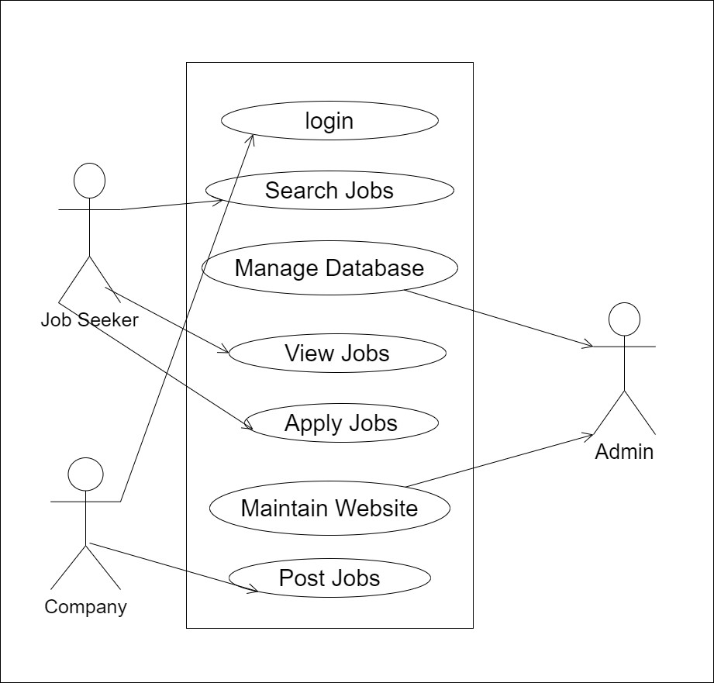

Figure 1: Use Case Diagram

The E-R diagram for our proposed system is shown below:

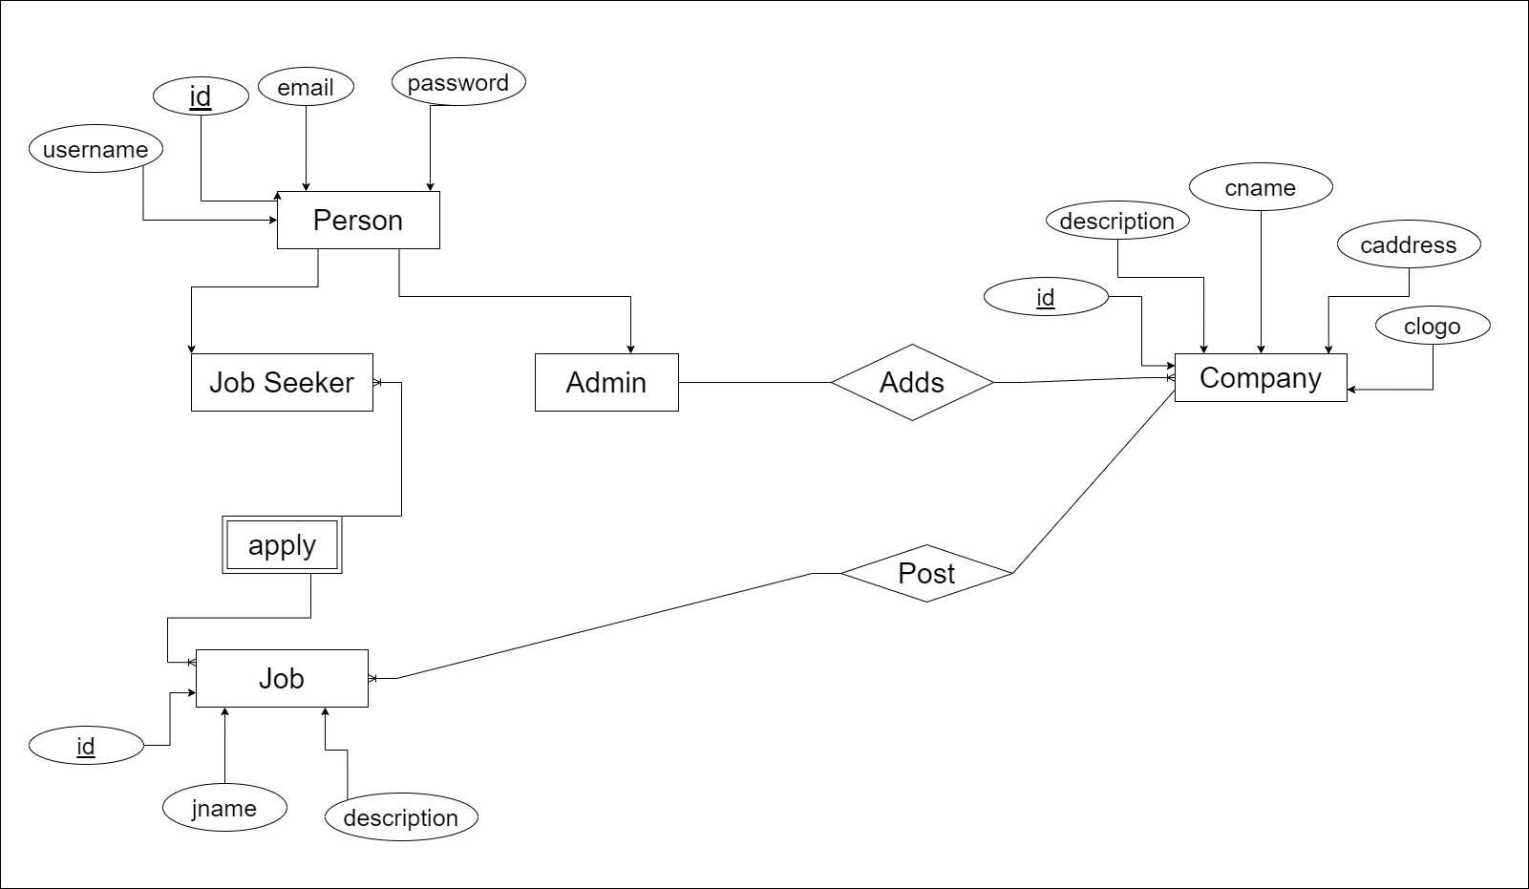

Figure 2: E-R Diagram

We will follow an incremental approach to develop this system .The project will be divided into several increments, each focusing on a specific functionality or component of the system. This approach allows us to build and test the system incrementally, ensuring continuous progress and feedback throughout the development process.

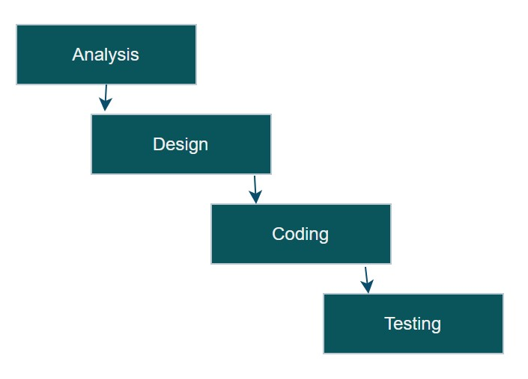

Figure 3: Increment Model

## Increment Model

This model combines linear sequential model with the iterative prototype model. New functionalities will be added as each increment is developed. The phases of the linear sequential model are: Analysis, Design, Coding and Testing. The software repeatedly passes through these phase in iteration and an increment is delivered with progressive changes.

## Technology and Frameworks

Overleaf

Overleaf is an online collaborative writing and publishing platform that allows users to create, edit, and share LaTeX documents. It provides a user-friendly interface with real-time collaboration features, making it easy for multiple authors to work together on a document simultaneously.We will be using using overleaf to prepare reports and documentation for the project.

Git

Git is a distributed version control system used for tracking changes in source code during software development. It allows multiple developers to collaborate on projects by managing a history of changes, merging different versions of code, and coordinating work across teams. It helps us in tracking changes in programs and coordinating work on those programs among the project team members.

Draw.io

Draw.io is a free and open-source software application that allows you to create and edit various types of graphical illustrations and diagrams. It provides a user-friendly interface with a wide range of tools and features for creating UML diagrams. These diagrams will be published in the final report and documentation.

HTML

HTML (HyperText Markup Language) is the standard language used to create and design web pages. It provides the structure and content of a web page by using various elements and tags to define different parts of the page, such as headings, paragraphs, links, images, and more. When combined with CSS (Cascading Style Sheets) for styling and JavaScript for interactivity, HTML forms the foundation of the modern web, allowing for the creation of dynamic and visually appealing websites and web applications.

PHP

PHP (Hypertext Preprocessor) is a popular server-side scripting language used for web development. It is widely used for creating dynamic web pages and web applications. PHP is embedded within HTML code and is executed on the server, generating HTML content that is then sent to the client’s web browser. PHP can interact with databases, manage user sessions, handle form data, and perform a wide range of other tasks necessary for web development. It is known for its flexibility, ease of use, and compatibility with various web servers and operating systems, making it a popular choice for building dynamic websites.

Figma

Figma is a cloud-based design and prototyping tool that allows users to create and collaborate on user interface (UI) designs. It provides a range of features such as real-time collaboration, vector editing, design components, and interactive prototyping. Figma is widely used in the design industry for creating visually appealing and interactive UI/UX designs. We will be using Figma in our project to create and refine the user interface design for our desktop application.

MySQL

MySQL is a popular open-source relational database management system. It allows users to store, organize, and manage structured data efficiently. We will be using MySQL as the backend database for our project to store and retrieve data related to attendance records, student information, and other relevant data.

# Conclusion and Future Extensions

In conclusion, job portals play a significant role in modern recruitment processes by connecting job seekers with employers and providing a platform for both parties to find suitable matches. These platforms offer a wide range of benefits, including:

* Provide easy access to a large number of job opportunities across various industriesand locations.
* Offer tools for posting jobs and managing applications
* Applicable for the jobless people and for the company who are searching for theemployee
* Strengthen data privacy and security measures.
* Make the system adaptable to different company.

## References

* <http://www.w3schools.com/>
* CRUD by Anirban Bhowmick
* PHP and MySQL by W Jason Gilmore, Press Publication
* Roger S. Pressman,Phd, Software Engineering: A Practitioner’s Approach, McGraw Hill,2010

APPENDIX